

Data element description language (DEDL) Plug-In Starter Kit
Installation and Administration Guide

EN-Node
.Net Version

Version: 1.0

December 23, 2011



1368 How Lane
North Brunswick, New Jersey 08902
www.enfotech.com

Revision History
Version | Date | Created By | Reviewed By | Description
1.0 | 12/21/2011 | Charlie Tsai |  | Release for public use

Tables of Contents

1 Document Purpose 4
2 Plug-In Overview 4
3 Installing the Plug-In 4
3.1 Prerequisites 4
3.2 Installation Package Contents 4
3.3 Installation Instructions 4
3.4 Test SubmitDEDL Schedule Task 6

Document Purpose
This purpose of this document is to provide guidance on the setup, use, and maintenance of the EN-Node Data Element Description Language (DEDL) Plug-ins.
The DEDL Plug-Ins will periodically retrieve current version of DEDL file in the EN-Node and then submit the DEDL file to EPA’s ENDS’ registry.

Plug-In Overview

One DEDL plug-ins is available under the DEDL data flow:
- SubmitDEDL: A schedule task that retrieve DEDL from EN-Node and sent it to ENDS.

Installing the Plug-In

Prerequisites
- EN-Node has been installed
- MS SQL Server has been installed

Installation Package Contents
This section identifies the files that are provided as part of the DEDL Plug-In Installation Package. The DEDL Plug-In Installation Package includes the following:

- SubmitDEDL _DataWizardConfig.xml: Node Plug-In Configuration file that defines the step-by-step logic for the SubmitDEDL Schedule Task
- USP_GET_DEDL__XML.sql: Stored procedure script which retrieve a DEDL XML file from EN-Node.

Installation Instructions
To create and configure the DEDL Node Plug-Ins please follow these steps:

- Run the following scripts in the existing Node database:
  - USP_GET_DEDL_XML.sql

- Update the …Wizard.xml files with your state or tribe specific database connection information:
  - Correct the connection string to point to your ENNode data source:
<parameter name="dataSource" value="MSSQL:server=xxxxx; database=xxxxx;UID=xxxxx; password=xxxxx;" type="System.String" />

  - Correct the NAAS Account Information with your state of tribe NAAS Admin account

<parameter name="authUser" value="xxxxx" type="System.String" />
<parameter name="authPassword" value="xxxxx" type="System.String" />

- Create SubmitDEDL Operation:
  - Log into the Node Administration Console. Under the Node Domains webpart, click the “Go to Operations” link for the Node Domain
  - Click “Create Operation by XML” button
  - Browse SubmitDEDL _DataWizardConfig.xml from the package.
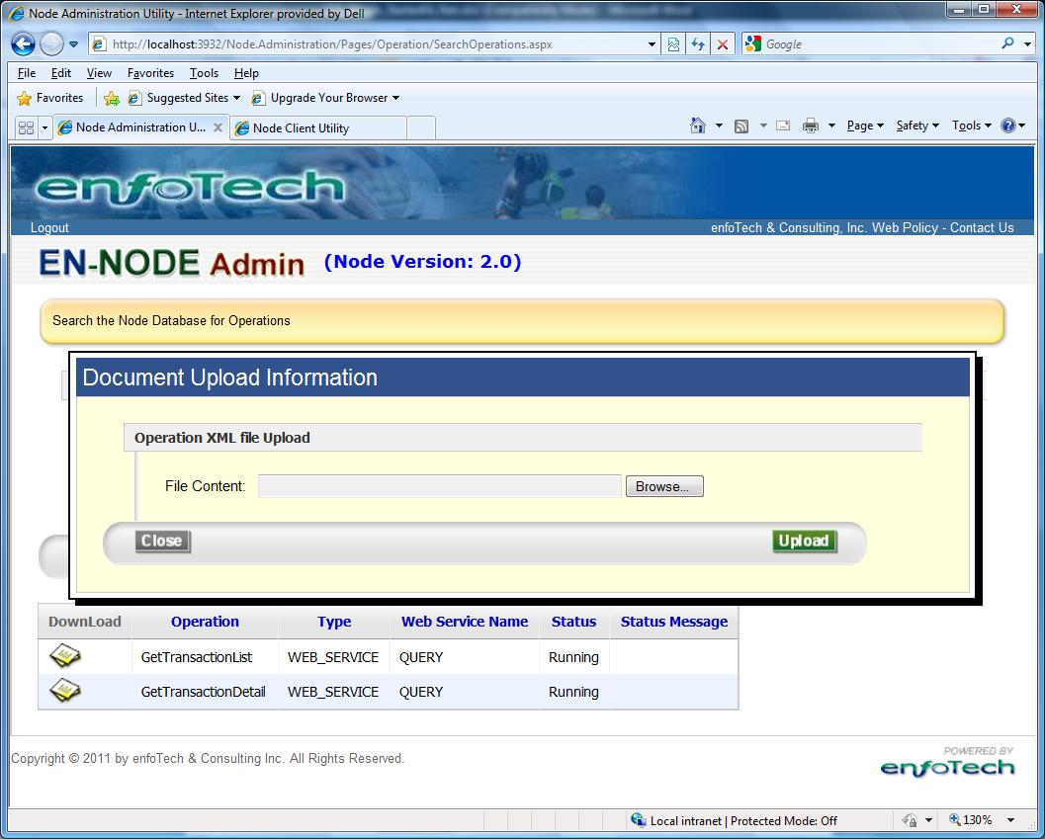
  - Click Upload to Create SubmitDEDL Operation.
  - The following information should shown on the operation information section :
    - Operation Name: SubmitDEDL
    - Operation Type: Schedule Task

Test SubmitDEDL Schedule Task
Since the plug-in is schedule task, you have to log into Node.Administration console to do the testing.
Step 1: Log into Node.Administration Console
- Log into the Node Administration Console. Under the Node Domains webpart, click the “Go to Operations” link for the Node Domain
- Click Edit icon to view the detail of SubmitDEDL operation.
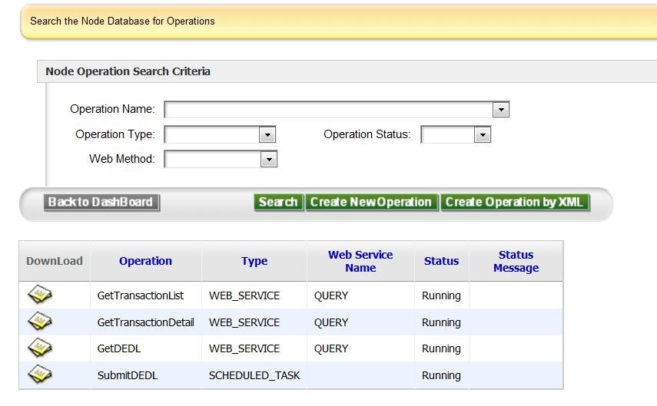

Step 2: Run SubmitDEDL Schedule Task
- Locate the Task Schedule Section under operation information detail.
- Input the following information for Task Schedule.
  - Task Schedule Type: Once
  - Start Date: Today’s Date
- Click Save button to save change schedule.
- The Schedule Task will be execute after two minutes
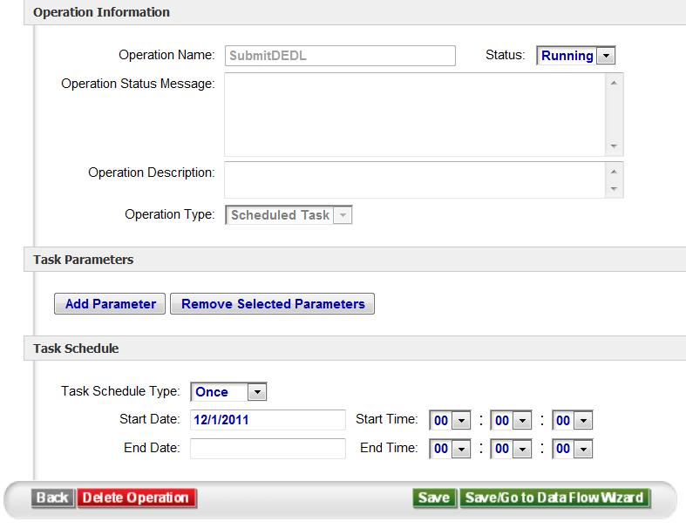

Step 3: Check SubmitDEDL Schedule Task
- Go back to home page and locate the Node Transaction Log web part
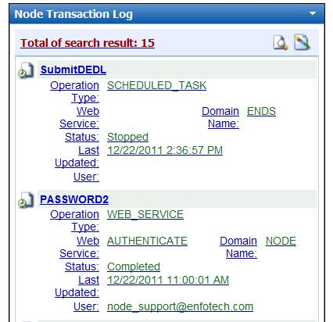
- Once the SubmitDEDL schedule task is executed, the transaction log will be created.
- Click on the SubmitDEDL link under the Node Transaction Log webpart. The detail of log will be shown as the following.
